Harvest Hands

Game Design Document

Goblin Hammer Games

# Team

Stephen Page – Team Lead

Stuart Wentworth – Artist

Josh Barber – Artist

Nathan Leaney – Artist

Nicholas Byrne – Programmer

Victor Brkic – Programmer

Coen Ambry – Designer

# Version History

|  |  |  |
| --- | --- | --- |
| Version | Author | Changes |
| 0.01 | Stephen Page | Initial document |
| 0.02 | Coen Ambry | Design Document Compiled |
| 0.03 | Coen Ambry | Document updated. Added more mechanics and further detailed their functionality. |
| 0.04 | Coen Ambry | Document revision due to moving forward onto major production. |
| 0.05 | Coen Ambry | Document re-write approaching project alpha. |

Table of Contents

*Team* 2

Version History 2

Harvest Hands 4

Concept 4

Feature Set 6

Genre 6

Game Flow 6

Look and Feel 6

Minimum Viable Product 6

Locations 7

Non Player Characters 7

Screens and User Interface 7

Screens 7

User Interface 7

Gameplay and Mechanics 8

Gameplay 8

Game Progression 8

Objectives 9

Mechanics 9

Core Mechanics 9

Physics 9

Objects 9

Dialogue/Shopping 10

Seeds 10

Economy 12

# Harvest Hands

## Concept

*Harvest Hands* is a cooperative sandbox farm management game for 1-4 players, who must work together to restore and build up a run-down farm. Players have a limited amount of daylight to complete their tasks and return to the farmhouse before nightfall, when monsters come out to prey on players.

The goal of *Harvest Hands* is to collect Gold, which can be used to upgrade the farm and purchase new crops. There are multiple ways to earn gold, with almost every activity in the game yielding some, but the players primary source of gold will be in growing and selling produce. Produce is grown from seeds, which can be found, crafted or bought in town. Other activities, such as fishing, foraging in the forest or cooking.

If the player does not return to the farmhouse by nightfall they will be killed, and any items they’re carrying have a 40% chance to be lost. Killed players respawn at the beginning of the next day in the farmhouse, and will have to venture out into the world again to recover their gear. This is designed to add a drive for players to act quickly and introduces a risk/reward system.

Players begin the game in the run-down Northwind Farm. The farm begins overgrown with weed, filled with debris and buildings in disrepair. Players start with their staff, a few seeds, some basic tools, and a bucket. They are required to clear all the debris before they can begin farming and building.

At the end of each day, every player’s gold will be pooled into a central farm budget. Each morning, 50% of the farm gold is divided amongst all players as a daily allowance. If a player wants to make an expensive purchase that goes beyond their budget, such as buying a boat, a vote will be triggered, and players choose whether or not to allow the deduction from the fam budget, or, if one is elected, the decision will be made by the farm manager.

Growing produce is done in multiple stages.

1. The player clears a location in a plot of land, relevant to the type of plant they wish to grow. A Root-type plant requires a single space of land, that will be freed once the plant is grown. A Berry-type plant takes up two spaces, and continues to grow produce after the first harvest, until it has been harvested four times. A Creep-type plant is planted in a single space, and will spread out continuously until harvested.
2. The player plants a seed by picking up the seed and placing it in the dirt.
3. The player waters the sapling with the bucket
4. The sapling begins to grow
5. The sapling gets bigger as the days go by, as long as players keep it watered.
6. The sapling grows produce
7. The player harvests the produce with a scythe

Players must also contend with random events that can trigger at the beginning of the day. A snap freeze can kill crops, rain will water plants but hinder other activities, vermin will attempt to eat the crops. This, combined with the random nature of the other mechanics will mean that no two games of *Harvest Hands* will play the same way, and will force the team to be more adaptable.

The Northwind Farm is made up from several areas, each with their own uses and mechanics.

* The Farmhouse is the central building of the farm. It is there at the start, albeit rundown, and can be repaired and upgraded twice.

1. The Kitchen is the first upgrade for the farmhouse. It allows players to access the cooking mechanic, to increase their profits
2. The Seed Shed is the other upgrade for the farmhouse, which allows players to process their produce into seeds

* The Animal Pen is used to store animals. It has a feeding trough to feed them produce.
* The Smoke House unlocks after you first obtain any kind of meat. It is used to prolong how long meat lasts by turning it into jerky.
* The Tool Shed is the where players can store tools so they are not destroyed during the night.
* The Garage is where the cart will spawn and be kept (once purchased)
* The Pier, located beside the Garage, is where players can fish, and where the boat will spawn and be kept (once purchased)

The Farm also contains a number of additional locations that serve a purpose to the player.

* The farm contains three storage bins, where players can safely store items to be sold later. The three bins are for crops, fish and cooked food.
* The Well allows players to fill their bucket’s without having to go to the river
* The Watering System allows players to water large areas at once

The town of Crasmere Keep is another central location in *Harvest Hands*, locating the majority of the shops the player will use, and is where they receive quests.

* The Inn is where a player can stay the night if they can’t make it back to the farm, for a fee
* The Royal Commission is where players can sell their crops, buy seeds, and receive quests
* The General Store, where players can purchase cosmetic items for their character
* The Pawn shop, where players can sell any items they’re carrying
* The Constructor’s Guild, where players can purchase upgrades and vehicles
* The Blacksmith, where players can purchase tools and weapons

Outside of the farm and castle is mainly forested wilderness. However, there are a few locations of note.

* Lyra’s Hollow is the location of the giant tree where the people of Crasmere make their offerings to the Nature Goddess, Lyra. This location is where players can offer up rare produce (Obtained through quests) to bless the land, allowing players to access higher tiered items
* The Dark Place is the home of the Witch Elana Vock, and the center of the curse. Player’s entering this area are instantly killed.

## Feature Set

* First Person Gameplay
* Upgrading and Maintaining a Farm
* Growing and Selling Produce
* Co-Operative Multiplayer
* Watering Crops
* Bucket empties after ‘charges’ spent
* Day/Night Cycle for growing plants
* Crops die if not watered
* Harvest crops with a scythe
* Harvested crops spawns a resource crate
* Convert crates into seeds
* Die if not safe by nightfall
* Delay between days
* Random Events
* Purchasing objects and upgrades
* Woodcutting
* Respawning trees
* Mushroom foraging
* Selling Items
* Depositing Items in chests
* Fishing
* Cooking
* Cosmetics
* Plant resistances & Weaknesses

## Genre

Simulation, Sandbox, Management, Farming, Fantasy

## Game Flow

The player moves throughout the game on foot.

You move through the game’s interface through menu buttons and the start menu.

## Look and Feel

The game will feature heavily stylized, hand painted textures. The color palette is mainly greens, and the game should feel like being in a vibrant fantasy world, filled with danger, magic and life.

## Minimum Viable Product

* Growing and Harvesting of three different plant types and at least 10 plants
* A functioning world economy
* Online Multiplayer
* Upgrading the Farm
* Progression through the tier system

## Locations

* Northwind Farm
* Crasmere Keep
* The Lake
* The Forest
* Lyra’s Hollow
* The Dark Place

## Non Player Characters

* King Waylon the Dragon
* The Witch Elana Vock
* High Mage Grigor Trunzo
* Shop Keepers

## Screens and User Interface

### Screens

* Main Menu
* Play
* Settings
* Quit
* Goblin Hammer Games
* Start Menu
* Resume
* Main Menu
* Shopping
* Buy
* Sell
* Exit

### User Interface

The UI will be as simple and minimalistic as possible. There should be no walls of text, and the gameplay should be designed such that the player should be able to work out the majority of the gameplay by experimentation.

For the things that the player can’t work out by experimentation, the UI should be clean, minimal and fit into the style and theme as unobtrusively as possible, fitting into the gameplay seamlessly.

UI Requirements:

* Clock and Time to show when night if coming and how long the player has to get to safety
* The farm’s current gold
* The player’s current gold
* The current day number

The UI will consist of a HUD, which is located in the top of the screen, in the center. This displays the four requirements in an unobtrusive way.  
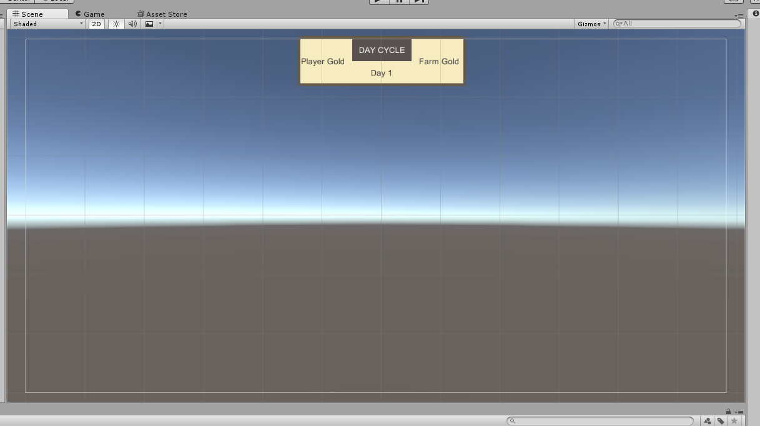

To view current players, the player can press a key (Tab, probably. Subject to change) which will bring up a magical list (Using the player’s staff to be diegetic)

# Gameplay and Mechanics

## Gameplay

### Game Progression

The game progresses by the player growing and selling produce. The more they sell, the more (and higher quality) seeds they can buy, creating the core game loop:

Plant Seeds > Maintain Crop > Harvest Crop > Sell Produce > Buy Seeds

### Objectives

The objective of the game is to grow food and maintain and upgrade your farm.

## Mechanics

### Core Mechanics

* Movement
* Growing Crops
* Harvesting Crops
* Picking Up Items
* Watering Plants
* Economy
* Cooking
* Fishing
* Foraging
* Upgrading the Farm

### Physics

The game will use standard Earth physics, with a force of gravity equal to 9.8N/second.

Almost any item can be picked up and held using the staff, and can be carried around, put down or thrown away, similar to the way that Half-Life’s Gravity Gun or Portal’s Portal Gun work. Any item that can be carried can also be interacted with in the game world without picking them up, which can be used as a feature if a player is stuck out in the open with an item on the ground and no space to hold it for example, they could then kick it along the ground for later retrieval.

#### Movement

The player can move along the ground in any direction, with the ability to sprint and jump. Unity’s default first-person controller is suitable for reaching the MVP but a new custom character controller should be developed afterwards.

### Objects

Useable objects will be highlighted lightly to indicate their possibility for interaction. When an object is used the player will pick it up and levitate it with their staff.

Objects are used by moving them into the correct area. For example, to use a scythe, you pick it up and touch a crop with it, which will harvest the crop. Another potential use would be bringing food onto the stove, which would initiate cooking.

The shopping system will require a mouse unlock.

### Dialogue/Shopping

The player can initiate the shopping interface by walking up to a shopkeeper. Using Unity’s UI and Trigger systems we will bring up the shopping interface to allow players to buy and sell items. To be as diegetic as possible we may use this as a sign or message board system rather than a floating menu that would break immersion.

### Seeds

Seeds are broken up into a tier system, with tier-1 seeds being the lowest valued, and the tier-4 seeds being the highest. Seeds are broken up into three varieties; Root, Berry and Creep.

Roots are a once-off plant that grows quickly and sells for a moderately higher value than what the seed’s worth.

Creep is also a once-off, and grows along the ground, spreading out from the original plant site. Creep can overtake other plants that are in the way, which give it a boost to growth. Creep harvesting can yield a high amount of produce that each sells for a small amount, but put together Creep can be more profitable than both Root and Berries.

Berry plants grow once, and can be continually harvested 4 more times before dying, without having to purchase new seeds. The ‘regrowth’ time is half of the original time for the plant to grow. Berry seeds take a long time to produce the first harvest, but are worth a lot and make a strong investment.

Each type of plant gives a different buff when cooking. Root plants heal the player. Berries make the player faster. Creep gives a profit bonus when selling items.

Grown plants must be harvested with the Scythe, and must be watered with the bucket whilst growing.

#### Seed list:

##### Roots

|  |  |  |  |  |  |
| --- | --- | --- | --- | --- | --- |
| Name | Description | Tier | Seed Price | Harvest Value | Harvest Amount |
| Weeping Root | This root is slightly psychic, and makes a screaming sound inside the head of anybody who touches it. | 1 |  |  |  |
| Heartblood | Said to be cultivated by ancient vampires, heartblood is an iron-rich root that makes a tasty soup. | 2 |  |  |  |
| Sunweed | A plant that glows faintly, when crushed up and mixed with water can produce a brilliant light. | 3 |  |  |  |
| Void’s Eye | An arcane root that contains the purest essences of magic, used by mages to make their staves, and goes well roasted with chicken. | 4 |  |  |  |

##### Berries

|  |  |  |  |  |  |
| --- | --- | --- | --- | --- | --- |
| Name | Description | Tier | Seed Price | Harvest Value | Harvest Amount |
| Knight’s Sorrow | According to legend, this berry was the only thing that could save an ancient knight’s lover. She died the day before he found it. Delicious, though. | 1 |  |  |  |
| Crowberry | Berries as grey as a crow’s feathers, a favorite of the middle class. | 2 |  |  |  |
| Snow Inkberry | The Snow Inkberry is the only Inkberry that is found in Crasmere, and is known for the thick white ‘ink’ that pours from its flesh when cut into. | 3 |  |  |  |
| Demon’s Bane | A small purple berry that is incredibly rare. The berries contain a powerful nature magic that kills demons, and makes a strong magical poison. Also tastes great in jam. | 4 |  |  |  |

##### Creeps

|  |  |  |  |  |  |
| --- | --- | --- | --- | --- | --- |
| Name | Description | Tier | Seed Price | Harvest Value | Harvest Amount |
| Widow’s Gore | This strong-smelling creep is often placed in coffins with the body, but is also a common cooking spice. | 1 |  |  |  |
| Tangling Chaos | A blood-red plant that spreads along the ground like a violent curse, but when cut into pieces is incredibly nutrient rich. | 2 |  |  |  |
| Feoxur’s Corruption | A black creep that will assimilate any plant it comes across, turning them black. It is a common spice, however, and is used in healing potions. | 3 |  |  |  |
| King’s Wealth | A golden plant that spreads out along the ground. Completely useless, but the King pays well for it. | 4 |  |  |  |

### Economy

The economy of *Harvest Hands* revolves around the collection of Gold pieces.